Kohltech International Architectural Details

Select Single Hung

System Features 2
Structural Performance 4
Thermal Performance 6
Section Details: Mullion Details 10
Section Details: Head/Sill, Jamb Details 12
Section Details: Mullion Details 14
Section Details: Head/Sill, Jamb Details 16
Section Details: Exterior Options 20
Section Details: Head/Sill, Jamb Details 24
Section Details: Interior Options 25

NOTE:
Specifications and technical data are subject to change without notice.
Allow 1/16” (2mm) tolerance on all measurements.
Metric measurements are shown in parenthesis.
For accessories dimensions and applications see the Accessories section of this manual.
For technical assistance you may call 1-800-565-4396 or visit our website:
www.peterkohler.com
 Select Single Hung

System Features

Frame:
- Standard is white extruded polyvinyl chloride (uPVC) profiles. Optional tan extruded.
- Operator/Fixed Frame depth: 3.25” (83mm)
- Small Picture Window Frame depth: 3.25” (83mm). This profile is used for shapes.

Sash:
- Standard is white extruded polyvinyl chloride (uPVC) profiles. Optional tan extruded.

Interior and exterior finish
- Interior finish: Standard high gloss white. Optional tan.
- Exterior finish: Standard high gloss white. Optional tan
- Additional colours are also available: waterborne single component color coating system which is chemically bonded to the exterior vinyl surface.

Hardware
- Truth lock and keeper
- John Evans constant force balance
- Stainless pivot bars

Weather Stripping:
. Two pile weather strip on sash

Jamb Extensions:
- Jamb extensions available for various depths and factory applied.

Insect Screens:
- White aluminum full screen standard. Optional tan to match tan extruded frame and sash.
- Screen mesh: grey fiberglass standard.
- Pull tabs integrated into screen corner

Interior / Exterior Simulated Divided Lites (SDL):
- Interior bar: Extruded vinyl or wood, 3/4” and 1” wide bars. Standard white. Optional tan or painted.
- Exterior bar: Extruded vinyl, 3/4” and 1” wide bars. Standard white. Optional tan or painted.
- Pattern: Rectangular, custom lite layouts available, contact your Kohltech International representative

Between the Glass Grilles:
- 3/4” Contoured Georgian. Standard white. Optional tan, painted any standard color, or spilt finish interior/exterior.
- 1” Contoured Georgian. Standard white. Optional painted any standard color.
- 5/8” Flat Colonial. Standard white. Optional tan, brass, brushed aluminum, painted.
- Slimline 5/16” Flat Colonial. Standard white. Optional tan, pewter, black, gold, mill finish, painted.
Select Single Hung

System Features

Glazing:
- Glazing method: Insulated glass, hermetically sealed
- Glazing seal: Tape glazed, silicone heel bead
- Glazing type: Clear glass
- Spacer type: Warm edge steel Intercept
- Options: soft coat LoE, argon gas fill, obscure glass, tinted glass, Energlas (LoE/Argon and Stainless Steel spacer), Energlas Plus (triple paned, 2 panes with LoE glass, argon gas filling, and Edgetech warm edge Superspacer)

Accessories:
- Standard: ½” to ¾” return is built into the frame on the interior.
- Optional: 7/8”,1½”; 2”, or 3 ½” brick molding all four sides or with subsill. All available with J-trim and nailing fin. 2” and 3 ½” brick molds available with decorative backband molding.
- Installation brackets
Select Single Hung

Structural Performance

Supreme Single Hung Series Performance Data – CSA A440
 | Gateway Size | Air Resistance | Water Resistance | Wind Load Resistance
Operating Single Hung | 40" x 63" (1015mm x 1600mm)  43-1/4” x 84” (1100mm x 2134mm)  50” x 72-5/8” (1272mm x 1846mm) | A3  A3  A3 | B7  B4  B5 | C5  C3  C3
Select Single Glider | 63" x 39" (1600mm x 1000mm) | A3 | B4 | C5
Picture Window | 50" x 100" (1267mm x 2540mm)  72” x 84” (1829mm x 2134mm) | FX  FX | B7  B7 | C3  C4

Supreme Single Hung Series Performance Data - NAFS
 | Gateway Size | Rating |  | Canadian Air Infiltration
Operating Single Hung | 40 x 63  43-1/4 x 84  50 x 72-5/8 | R-PG70-H  LC-PG40-H  R-PG50-H |  | A3  A3  A3
Select Single Glider | 63 x 39 | R-PG40-H |  | A3
Picture Window | 50 x 100  72 x 84 | R-PG50-FW  CW-PG60-FW |  | FX  FX
Select Single Hung

Structural Performance

CSA A440-00 Performance Class Indicators
Air Infiltration (Test Pressure = 75 Pa) |  |  | Water Infiltration |  |  |  |  | Wind Load Resistance
Infiltration (m³/h/m²) | Rating |  | Test Pressure (Pa) |  | Rating |  |  | Test Pressure (Pa) |  |  | Rating
≤ 2.97 | A1 |  | 150 |  | B1 |  |  | ± 500 |  |  | C1
≤ 1.65 | A2 |  | 200 |  | B2 |  |  | ± 750 |  |  | C2
≤ 0.55 | A3 |  | 300 |  | B3 |  |  | ± 1200 |  |  | C3
≤ 0.25 | FX |  | 400 |  | B4 |  |  | ± 1600 |  |  | C4
 |  |  | 500 |  | B5 |  |  | ± 2000 |  |  | C5
 |  |  | 600 |  | B6
 |  |  | 700 |  | B7
NAFS (AAMA/CSA-A440) Performance Grade Indicators
Product Performance Classes |  | Minimum Performance Grade |  | Minimum Design Pressure |  |  | Minimum Structural Test Pressure |  |  | Minimum Water Penetration Test Pressure
 |  | PG |  | psf |  | (Pa) | psf |  | (Pa) | psf |  | (Pa)
R – Residential |  | 15 |  | 15 |  | (719) | 2.90 |  | (137) | 2.90 |  | (137)
LC – Light Commercial |  | 25 |  | 25 |  | (1198) | 3.75 |  | (180) | 3.75 |  | (180)
CW – Commercial |  | 30 |  | 30 |  | (1437) | 4.50 |  | (217) | 4.50 |  | (217)
AW – Architectural |  | 40 |  | 40 |  | (1916) | 8.00 |  | (383) | 8.00 |  | (383)

Select Single Hung

Thermal Performance

Select Single Hung Series Average Unit Thermal Performance Data
 | U-value Btu/h•ft.²•°F (W/m²•K) | R-value | SHGC | VT | ER Number | Condensation Resistance | Canadian Energy Star Zone | US Energy Star
Operating Single Hung
Clear Glass (2012) | 0.48 (2.7) | 2.08 | 0.6 | 0.63 | 14 | 46 | N/A | N/A
LoE (2012) | 0.37 (2.1) | 2.7 | 0.55 | 0.63 | 25 | 50 | N/A | N/A
LoE/Argon (2012) | 0.34 (1.9) | 2.94 | 0.55 | 0.63 | 29 | 53 | ABC | N/A
LoE – LSG (2012) | 0.35 (2.0) | 2.85 | 0.31 | 0.56 | 14 | 51 | N/A | N/A
LoE/Argon – LSG (2012) | 0.32 (1.8) | 3.13 | 0.31 | 0.56 | 17 | 54 | A | N/A
Energlas (2012) | 0.33 (1.9) | 3.03 | 0.55 | 0.63 | 30 | 56 | ABC | N/A
Energlas – LSG (2012) | 0.31 (1.8) | 3.23 | 0.31 | 0.56 | 19 | 57 | A | NC

Select Single Hung Series Average Unit Thermal Performance Data
 | U-value Btu/h•ft.²•°F (W/m²•K) | R-value | SHGC | VT | ER Number | Condensation Resistance | Canadian Energy Star Zone | US Energy Star
Single Hung Glider
Clear Glass (2012) | 0.48 (2.7) | 2.08 | 0.6 | 0.63 | 14 | 45 | N/A | N/A
LoE (2012) | 0.37 (2.1) | 2.7 | 0.55 | 0.63 | 25 | 51 | N/A | N/A
LoE/Argon (2012) | 0.34 (1.9) | 2.94 | 0.55 | 0.63 | 29 | 53 | ABC | N/A
LoE – LSG (2012) | 0.35 (2.0) | 2.85 | 0.31 | 0.55 | 14 | 52 | N/A | N/A
LoE/Argon – LSG (2012) | 0.32 (1.8) | 3.13 | 0.31 | 0.55 | 17 | 54 | A | N/A
Energlas (2012) | 0.33 (1.9) | 3.03 | 0.55 | 0.63 | 30 | 57 | ABC | N/A
Energlas – LSG (2012) | 0.31 (1.8) | 3.23 | 0.31 | 0.55 | 19 | 58 | A | NC
Select Single Hung
Thermal Performance

Select Single Hung Series Average Unit Thermal Performance Data
 | U-value Btu/h•ft.²•°F (W/m²•K) | R-value | SHGC | VT | ER Number | Condensation Resistance | Canadian Energy Star Zone | US Energy Star
Picture Window
Clear Glass (2012) | 0.47 (2.7) | 2.13 | 0.62 | 0.66 | 17 | 47 | N/A | N/A
LoE (2012) | 0.35 (2.0) | 2.85 | 0.58 | 0.67 | 30 | 52 | ABC | N/A
LoE/Argon (2012) | 0.31 (1.8) | 3.23 | 0.58 | 0.67 | 35 | 55 | ABCD | N
LoE – LSG (2012) | 0.33 (1.9) | 3.03 | 0.32 | 0.58 | 17 | 53 | N/A | N/A
LoE/Argon – LSG (2012) | 0.29 (1.6) | 3.45 | 0.32 | 0.58 | 22 | 56 | A | N, NC
Energlas (2012) | 0.31 (1.8) | 3.23 | 0.58 | 0.67 | 35 | 58 | ABCD | N
Energlas – LSG (2012) | 0.29 (1.6) | 3.45 | 0.32 | 0.58 | 22 | 59 | A | N, NC
Select Single Hung

Thermal Performance

Canadian Energy Star Climate Zones
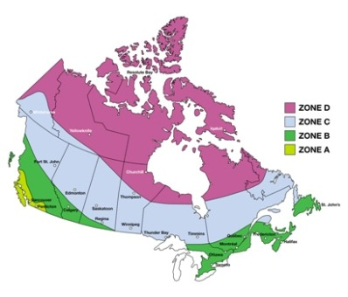

Energy Star Requirements for Windows ⁽²⁰⁰⁴⁾
 |  | Maximum U-values  and Minimum R-Values |  |  |  |  | Minimum  Energy Rating (ER) Values  (Maximum U-value 2.00 W/m²•K)
Zone | U-value  (W/m²•K) |  | U-value  (Btu/h•ft.²•°F) | R-Value  (ft.²•h•°F/Btu) |  |  |  | Operating Windows | Fixed  Windows
A | 2.00 |  | 0.35 | 2.9 |  | Or |  | 17 | 27
B | 1.80 |  | 0.32 | 3.2 |  | Or |  | 21 | 31
C | 1.60 |  | 0.28 | 3.6 |  | Or |  | 25 | 35
D | 1.40 |  | 0.25 | 4.0 |  | Or |  | 29 | 39

For more information please visit:
http://oee.nrcan.gc.ca/energystar/english/consumers/ratings.cfm

Select Single Hung

Thermal Performance

United States Energy Star Climate Zones

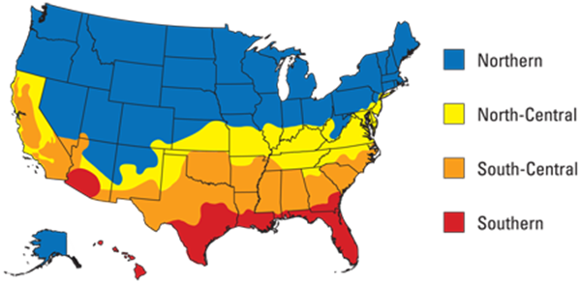

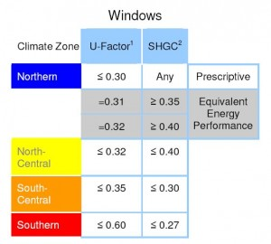
Select Single Glider

Section Details: Mullion

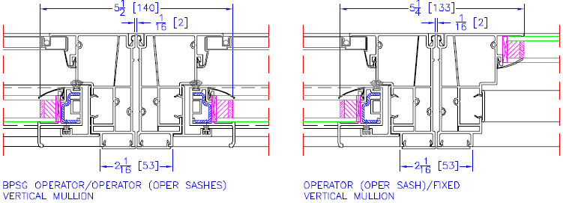

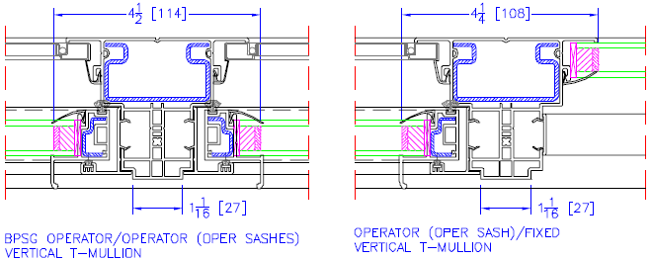

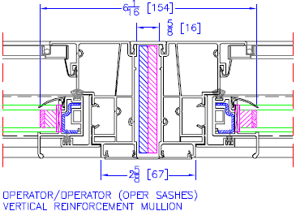
Select Single Glider

Section Details: Mullion
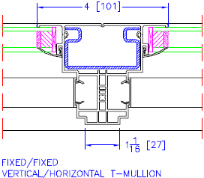
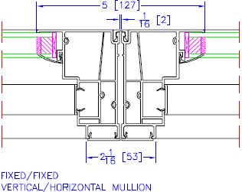

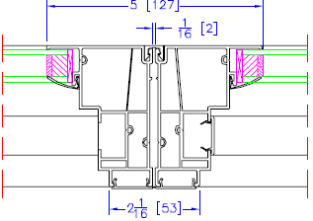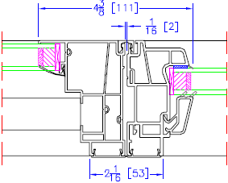

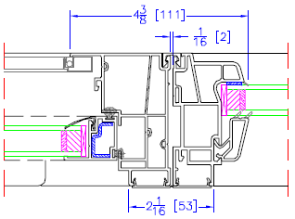
Select Single Glider

Section Details: Head/Sill, Jamb
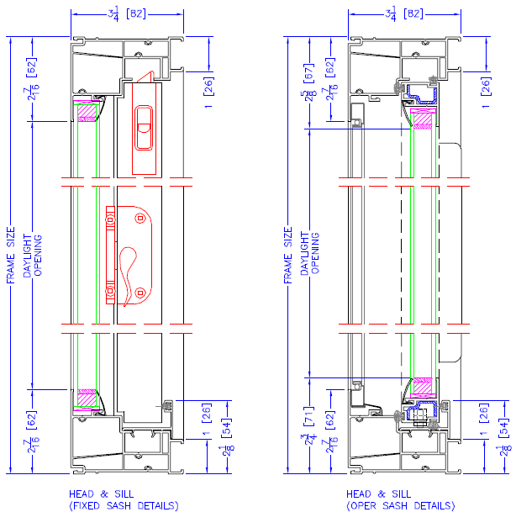
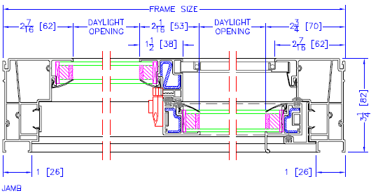
Select Single Glider

Section Details: Head/Sill, Jamb Details, w/ 1- ½” Integral BM

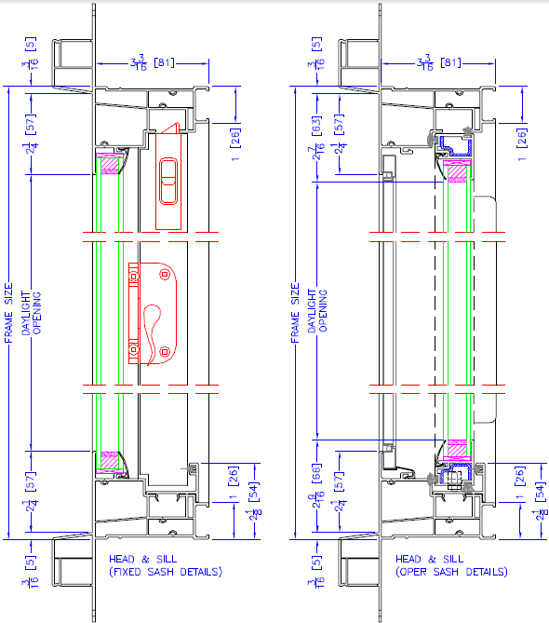
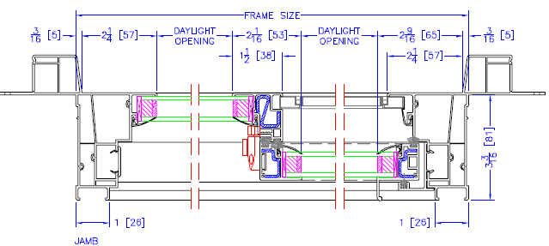
Select Single Hung

Section Details: Mullion

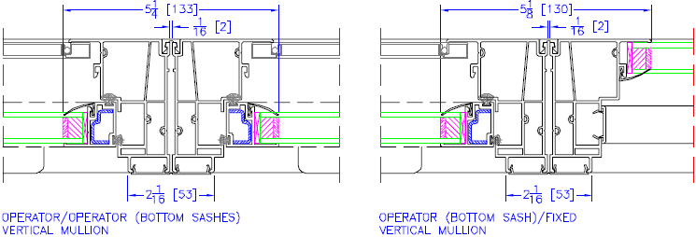

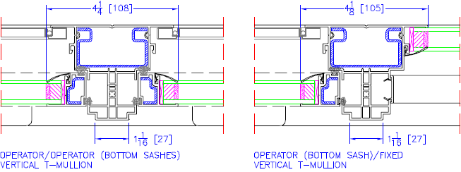
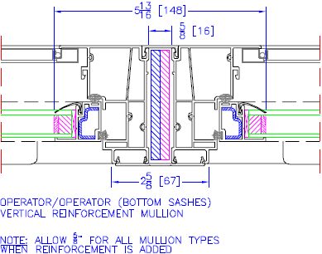
Select Single Hung

Section Details: Mullion

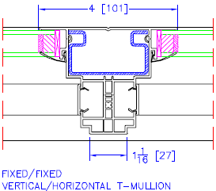
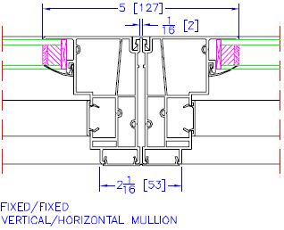

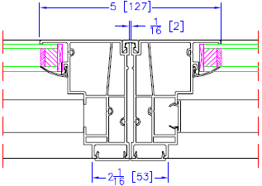
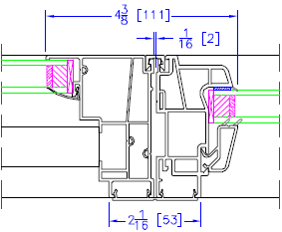


Select Single Hung

Section Details: Head/Sill, Jamb Details

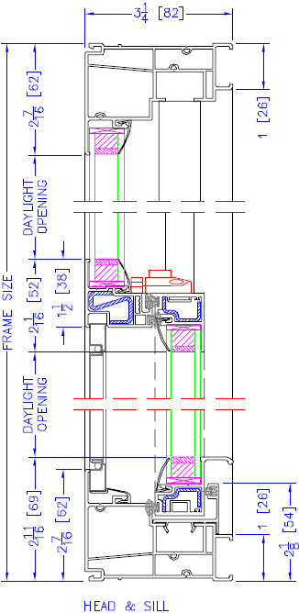
Select Single Hung

Section Details: Head/Sill, Jamb Details

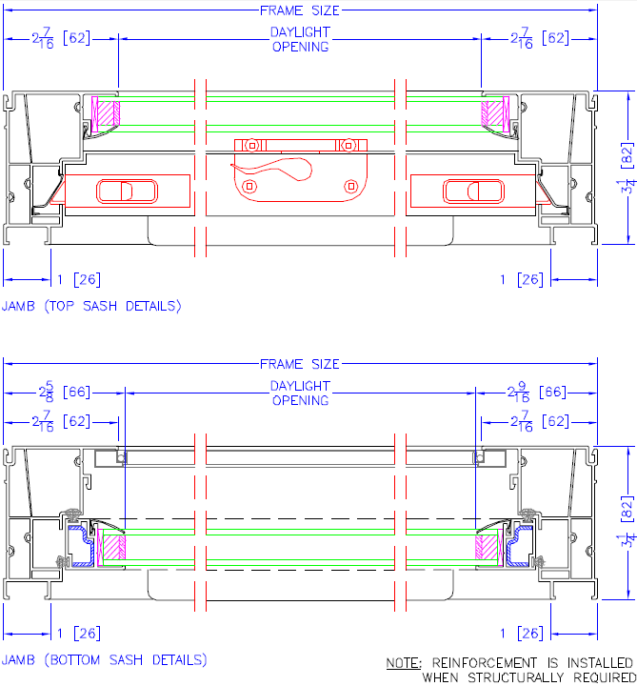
Select Single Hung

Section Details: Head/Sill, Jamb Details, w/ 1-1/2” Integral BM

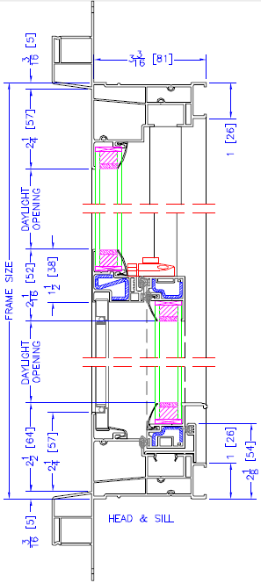

Select Single Hung

Section Details: w/ 1-1/2” Integral BM, Head/Sill, Jamb Details

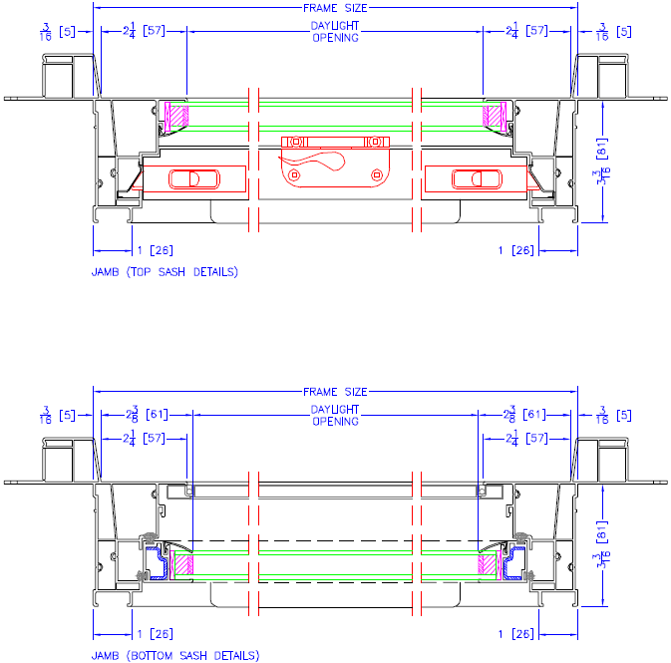


Select Single Hung/Glider

Section Details: Exterior Options

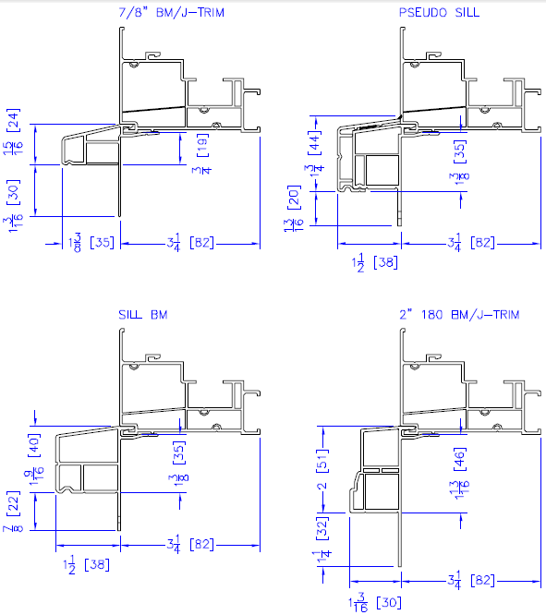

Select Single Hung/Glider

Section Details: Exterior Options

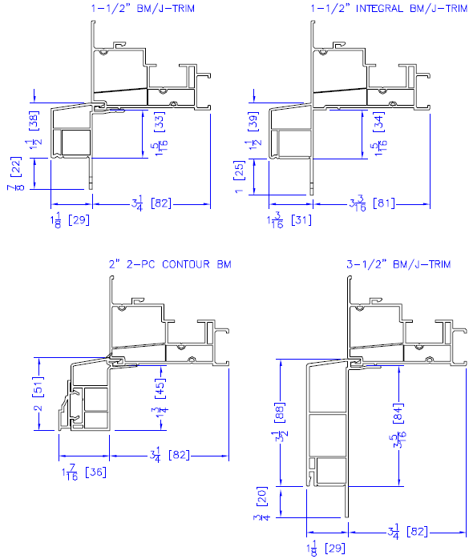
Select Single Hung/Glider

Section Details: Exterior Options
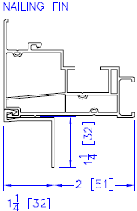
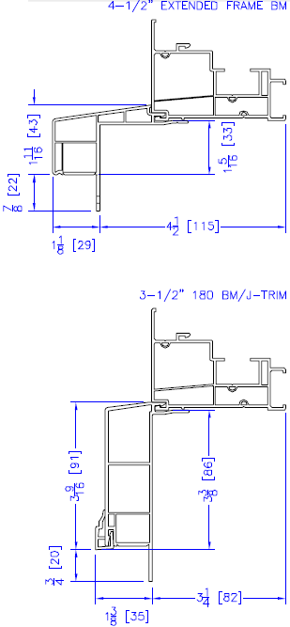

Select Single Hung/Glider Fixed

Section Details: Exterior Options

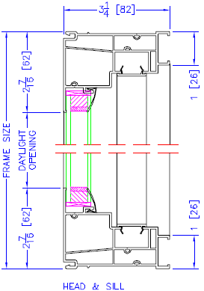

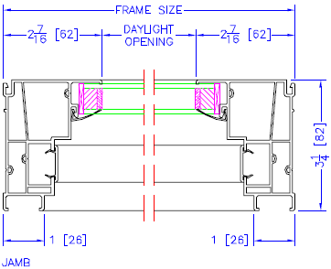
Select Single Hung/Glider Fixed

Section Details: w/ 1-1/2” Integral BM, Head/Sill, Jamb Details
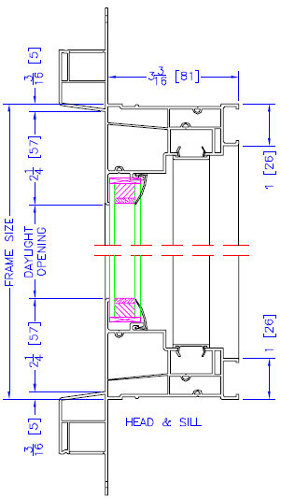
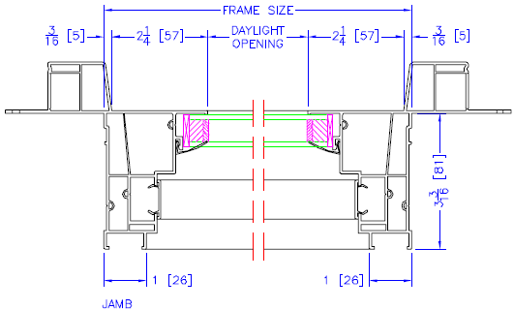
Select Single Hung/Glider

Section Details: Interior Options

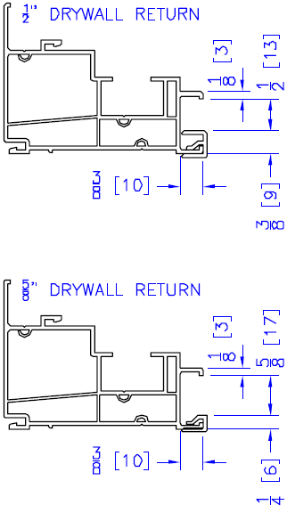
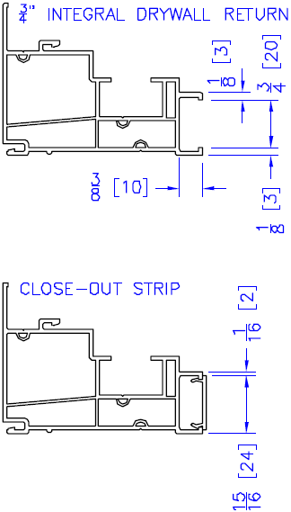
Select Single Hung/Glider

Section Details: Interior Options
