Kohltech International Architectural Details

Wood Entrance Doors

System Features 2
Structural Performance 4
Thermal Performance 5
4-5/8” In-swing Single 6
4-5/8” Out-swing Single 7
6-5/8” In-swing Single 8
6-5/8” Out-swing Single 9
4-5/8” In-swing Double Door (or Single with Furniture Sidelite) 10
4-5/8” Out-swing Double Door (or Single with Furniture Sidelite) 11
6-5/8” In-swing Double Door (or Single with Furniture Sidelite) 12
6-5/8” Out-swing Double Door (or Single with Furniture Sidelite) 13
4-5/8” In-swing Garden Door 14
4-5/8” Out-swing Garden Door 15
6-5/8” In-swing Garden Door 16
6-5/8” Out-swing Garden Door 17
4-5/8” In-swing Sidelite 18
4-5/8” Out-swing Sidelite 19
6-5/8” In-swing Sidelite 20
6-5/8” Out-swing Sidelite 21
4-5/8” In-swing S-100 22
4-5/8” Out-swing S-100 23
6-5/8” In-swing S-100 24
6-5/8” Out-swing S-100 25
4-5/8” In-swing Transom 26
4-5/8” Out-swing Transom 27
6-5/8” In-swing Transom 28
6-5/8” Out-swing Transom 29
In-swing Vertical Mullions 30
Out-swing Vertical Mullions 31
In-swing Horizontal Mullions 32
Out-swing Horizontal Mullions 33
In-swing Storm Door Prep on Post 34
Exterior Options 35
In-swing Sill Options 36
Out-swing Sill Options 37
6-5/8” Out-swing Vented Panel 38
6-5/8” Out-swing Vented Panel – Vertical Mullion 39

System Features

Frame:
- Standard is white extruded polyvinyl chloride (uPVC) profiles. Optional tan extruded.
- Operator/Fixed Frame depth: 3.25” (83mm)
- Small Picture Window Frame depth: 3.25” (83mm). This profile is used for shapes.

Sash:
- Standard is white extruded polyvinyl chloride (uPVC) profiles. Optional tan extruded.

Interior and exterior finish
- Interior finish: Standard high gloss white. Optional tan.
- Exterior finish: Standard high gloss white. Optional tan
- Additional colours are also available: waterborne single component color coating system which is chemically bonded to the exterior vinyl surface.

Hardware
- Truth lock and keeper
- John Evans constant force balance
- Stainless pivot bars

Weather Stripping:
- Two pile weather strip on sash

Jamb Extensions:
- Jamb extensions available for various depths and factory applied.

Insect Screens:
- White aluminum full screen standard. Optional tan to match tan extruded frame and sash.
- Screen mesh: grey fiberglass standard.
- Pull tabs integrated into screen corner

Interior / Exterior Simulated Divided Lites (SDL):
- Interior bar: Extruded vinyl or wood, 3/4” and 1” wide bars. Standard white. Optional tan or painted.
- Exterior bar: Extruded vinyl, 3/4” and 1” wide bars. Standard white. Optional tan or painted.
- Pattern: Rectangular, custom lite layouts available, contact your Kohltech International representative

Between the Glass Grilles:
- 3/4” Contoured Georgian. Standard white. Optional tan, painted any standard color, or spilt finish interior/exterior.
- 1” Contoured Georgian. Standard white. Optional painted any standard color.
- 5/8” Flat Colonial. Standard white. Optional tan, brass, brushed aluminum, painted.
- Slimline 5/16” Flat Colonial. Standard white. Optional tan, pewter, black, gold, mill finish, painted.

Glazing:
- Glazing method: Insulated glass, hermetically sealed
- Glazing seal: Tape glazed, silicone heel bead
- Glazing type: Clear glass
- Spacer type: Warm edge steel Intercept
- Options: soft coat LoE, argon gas fill, obscure glass, tinted glass, Energlas (LoE/Argon and Stainless Steel spacer), Energlas Plus (triple paned, 2 panes with LoE glass, argon gas filling, and Edgetech warm edge Superspacer)

Accessories:
- Standard: ½” to ¾” return is built into the frame on the interior.
- Optional: 7/8”,1½”; 2”, or 3 ½” brick molding all four sides or with subsill. All available with J-trim and nailing fin. 2” and 3 ½” brick molds available with decorative backband molding.
- Installation brackets

NOTE:
Specifications and technical data are subject to change without notice.
Allow 1/16” (2mm) tolerance on all measurements.
Metric measurements are shown in parenthesis.
For accessories dimensions and applications see the Accessories section of this manual.
For technical assistance you may call 1-800-565-4396 or visit our website:
www.peterkohler.com

Structural Performance

Estate Double Hung Series Performance Data - NAFS
 | Gateway Size | Rating | Canadian Air Infiltration
Steel Entrance | 37.5 x 82.375  37.5 x 81.625  37.625 x 82.5625  37.625 x 81.8125 | R-PG30-SHD LW  R-PG25-SHD LW  R-PG35-SHD LW  R-PG25-SHD LW | A2  A2  A3  A3
Steel Sidelite | N/A | N/A | N/A
Fibreglass Entrance | 37.5 x 82.375  37.5 x 81.625  37.5 x 82.375  37.5 x 81.625 | R-PG40-SHD LW  R-PG40-SHD LW  R-PG25-SHD LW  R-PG25-SHD LW | A2  A2  A2  A2
Fibreglass Sidelite | N/A | N/A | N/A
Garden Door | 75 x 82.375  75 x 82.375  75 x 82.375 | R-PG40-SHD LW  R-PG20-SHD LW  R-PG35-SHD LW | A3  A3  A3
Double Door | 104.375 x 95.5625  104.875 x 95.5625  105.9375 x 96.625 | R-PG15-SHD LW  R-PG15-SHD LW  R-PG15-SHD LW | A2  A2  A2
Combination Door | 104.375 x 95.5625  104.875 x 95.5625  105.9375 x 96.625 | R-PG15-SHD LW  R-PG15-SHD LW  R-PG15-SHD LW | A2  A2  A2
S100 Transom | 104.375 x 95.5625 | N/A | N/A
S-100 Sidelite | 104.375 x 95.5625 | N/A | N/A
Door Picture Window | 47.24x59.06 | N/A | N/A

Thermal Performance

With the exception of most of the clear glass options, all Kohltech / Peter Kohler door systems are Energy Star certified. Please check with you nearest Kohltech / Peter Kohler dealer for information on your particular door system.

4-5/8” In-swing Single
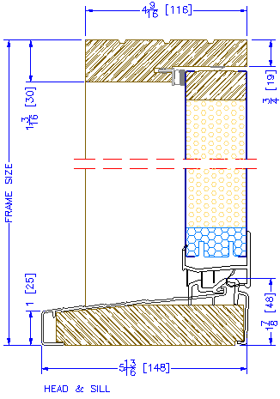

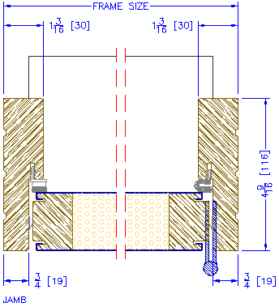

4-5/8” Out-swing Single

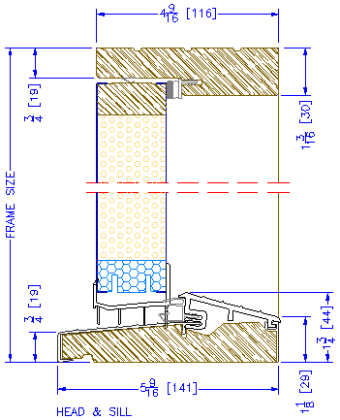

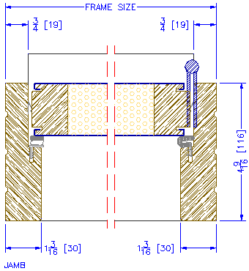

6-5/8” In-swing Single
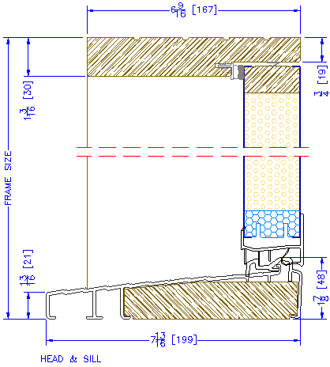

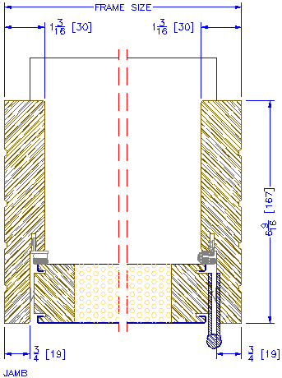

6-5/8” Out-swing Single
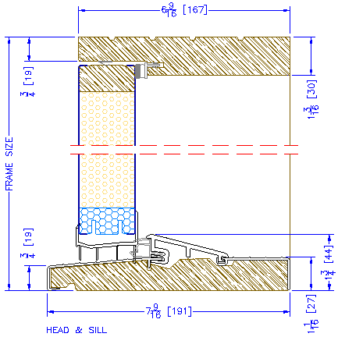

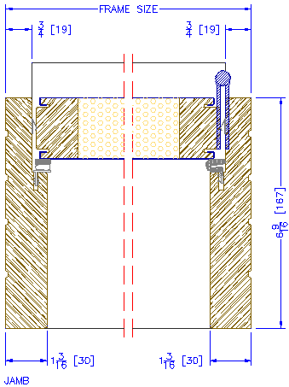

4-5/8” In-swing Double Door (or Single with Furniture Sidelite)

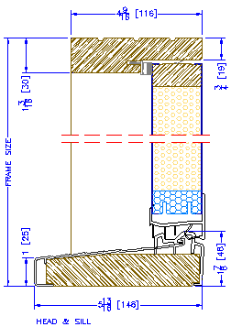

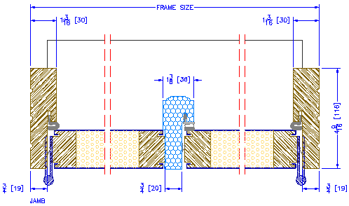

4-5/8” Out-swing Double Door (or Single with Furniture Sidelite)

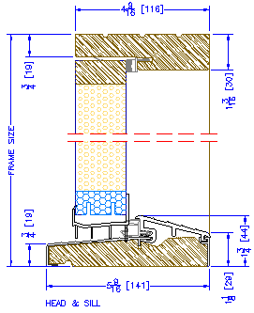

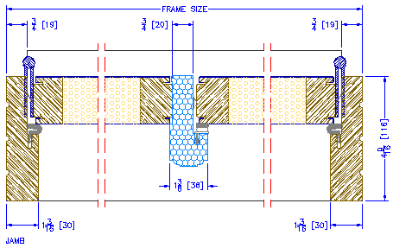

6-5/8” In-swing Double Door (or Single with Furniture Sidelite)

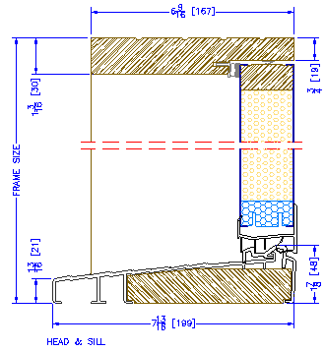

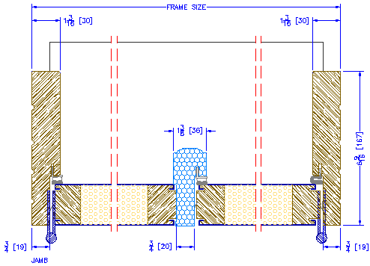

6-5/8” Out-swing Double Door (or Single with Furniture Sidelite)

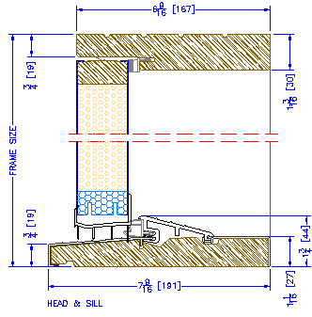

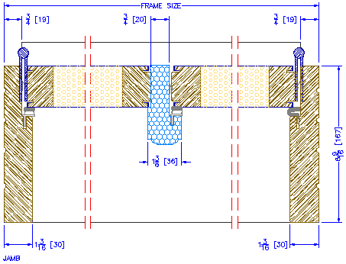

4-5/8” In-swing Garden Door

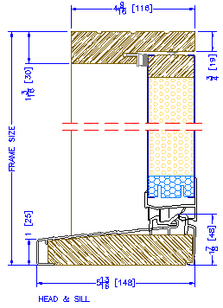

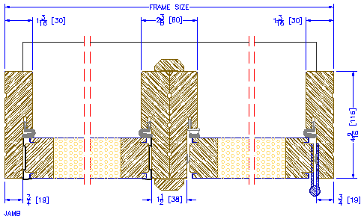

4-5/8” Out-swing Garden Door

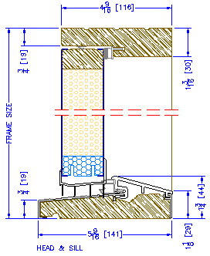

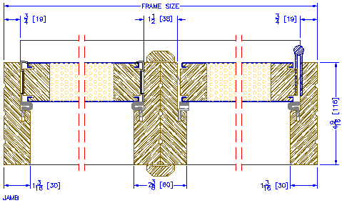

6-5/8” In-swing Garden Door

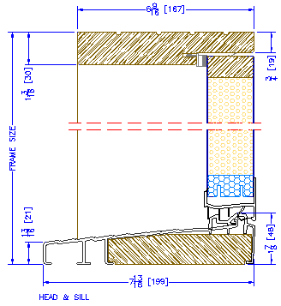

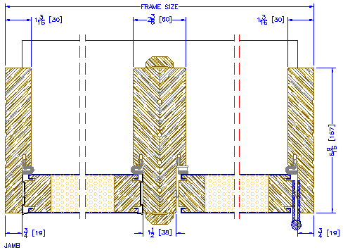

6-5/8” Out-swing Garden Door

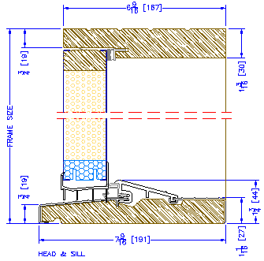

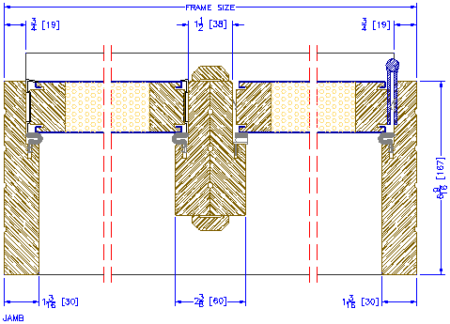

4-5/8” In-swing Sidelite
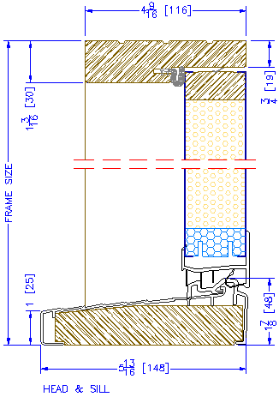

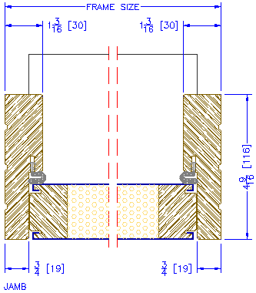

4-5/8” Out-swing Sidelite

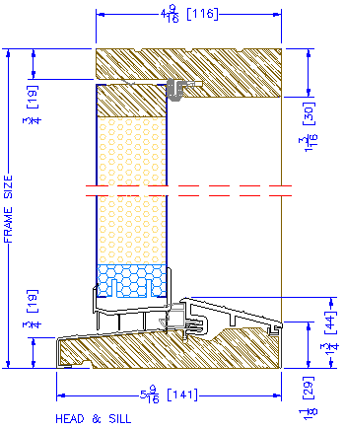

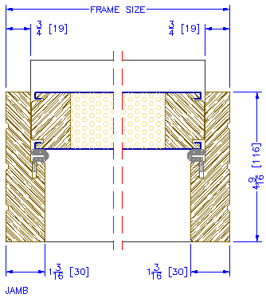

6-5/8” In-swing Sidelite
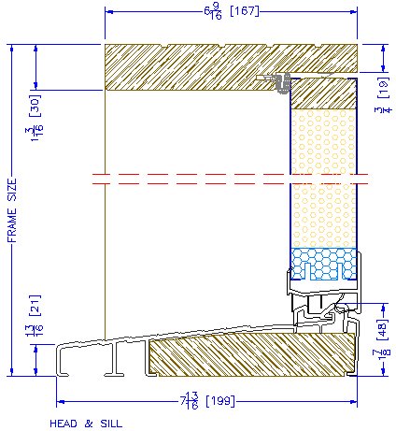

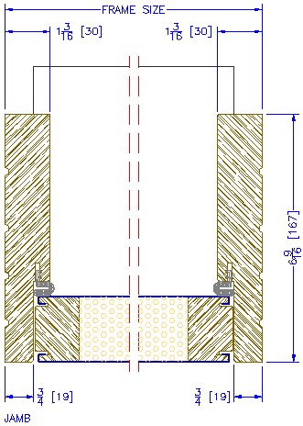

6-5/8” Out-swing Sidelite
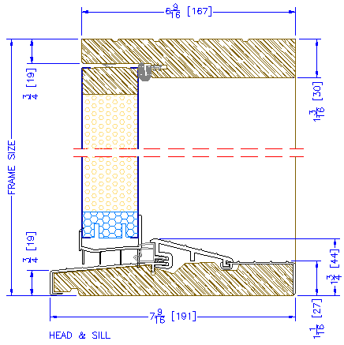

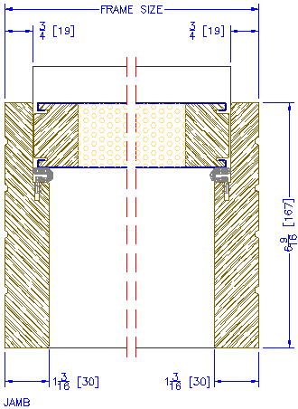

4-5/8” In-swing S-100
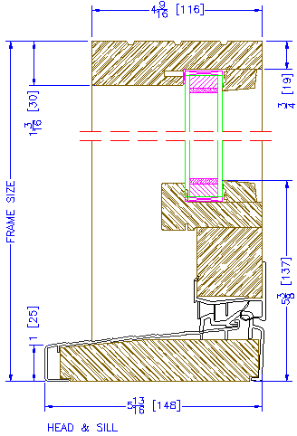

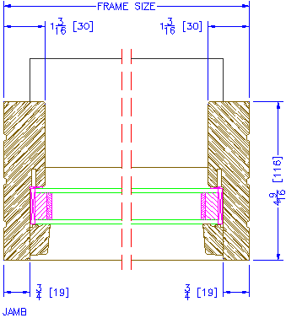

4-5/8” Out-swing S-100

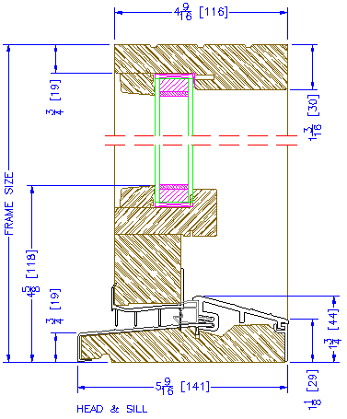

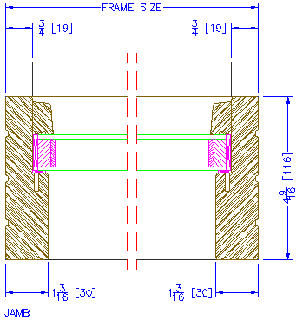

6-5/8” In-swing S-100
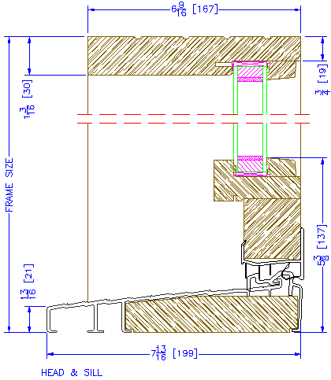

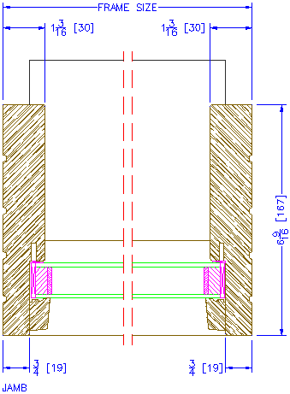

6-5/8” Out-swing S-100
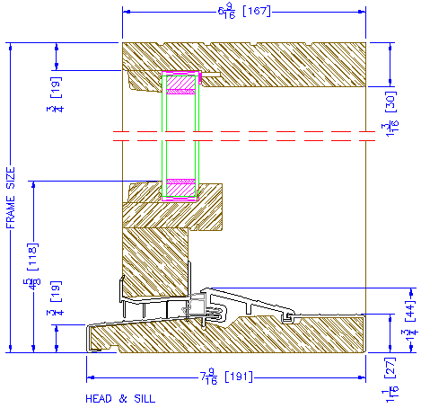

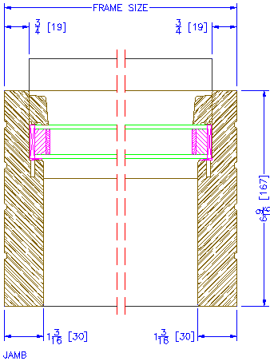

4-5/8” In-swing Transom

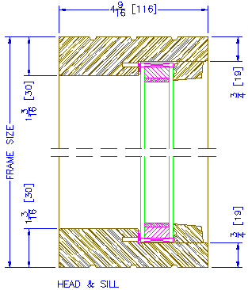

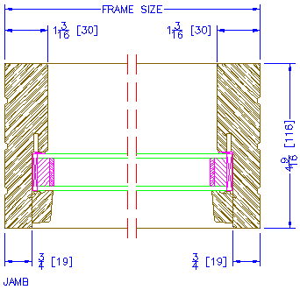

4-5/8” Out-swing Transom

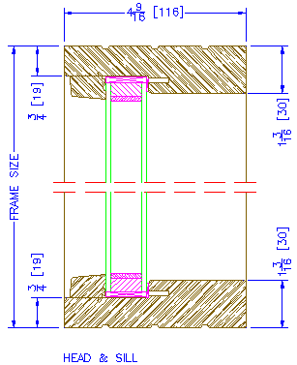

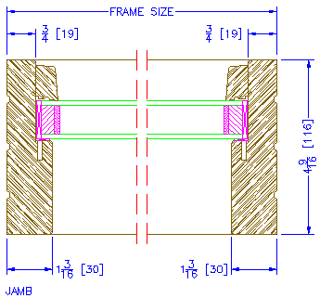

6-5/8” In-swing Transom

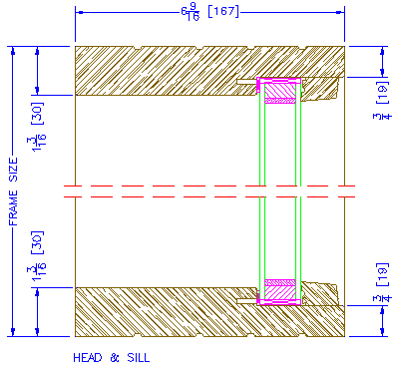

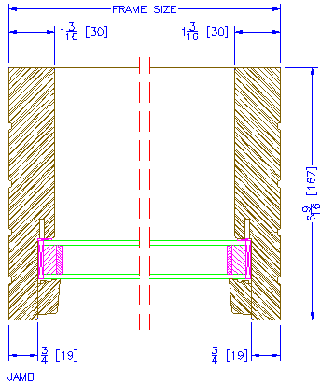

6-5/8” Out-swing Transom

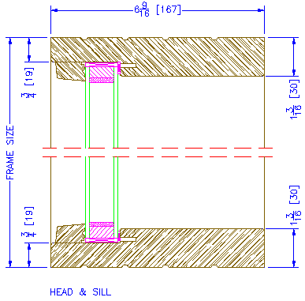

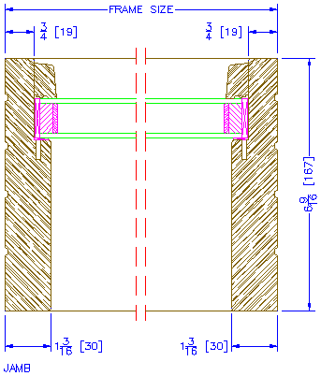

In-swing Vertical Mullions

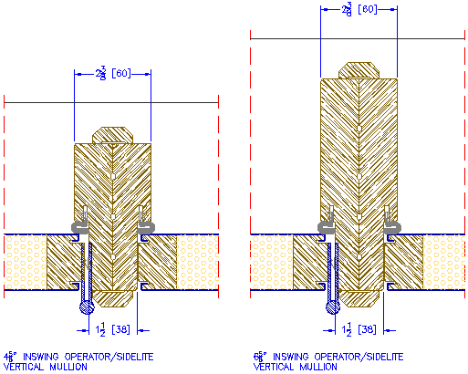

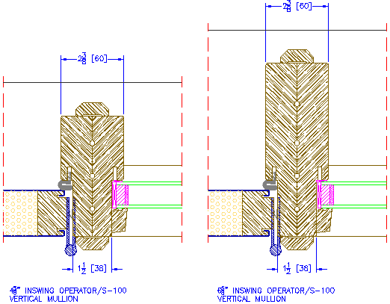

Out-swing Vertical Mullions
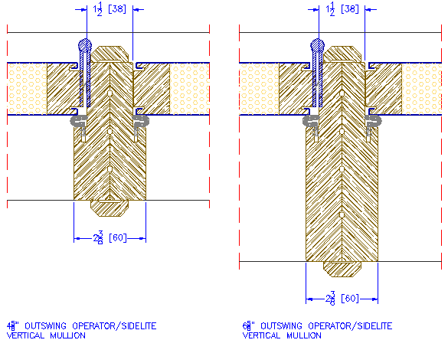

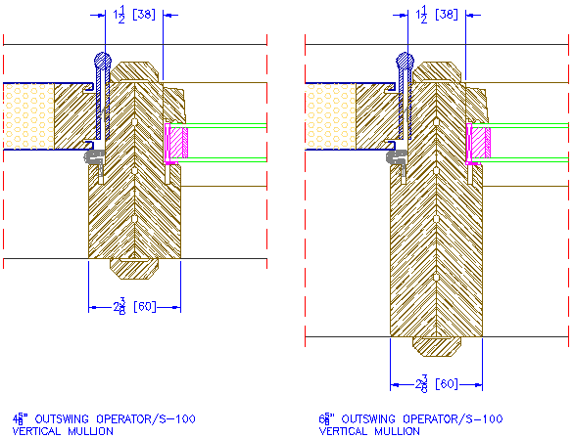

In-swing Horizontal Mullions

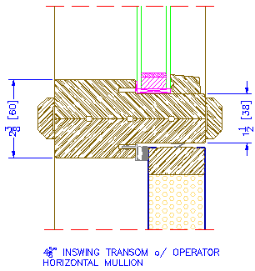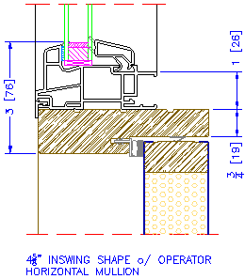

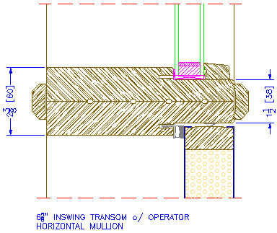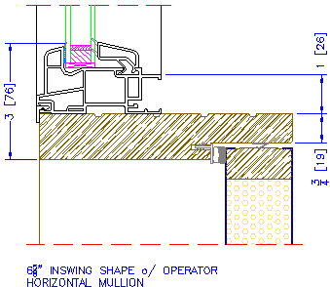

Out-swing Horizontal Mullions

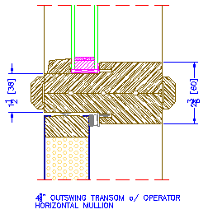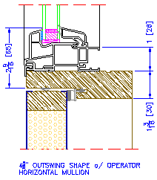

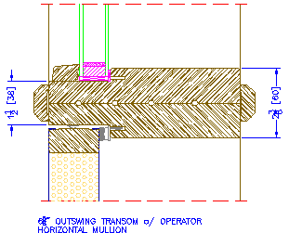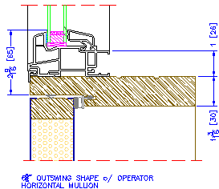

In-swing Storm Door Prep on Post

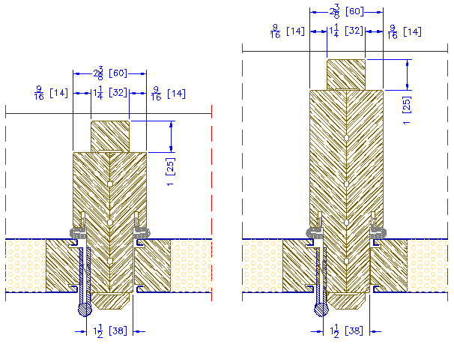

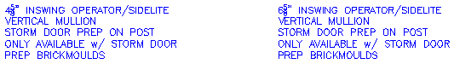

Exterior Options

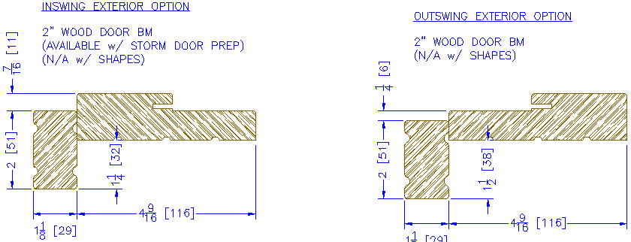

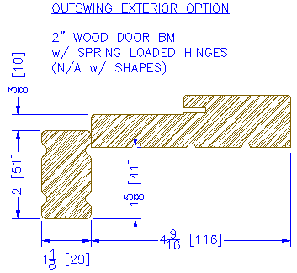



In-swing Sill Options

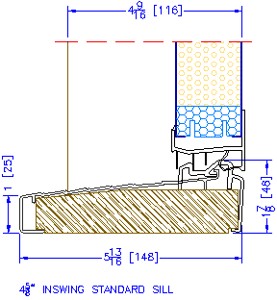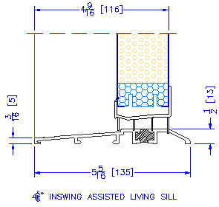

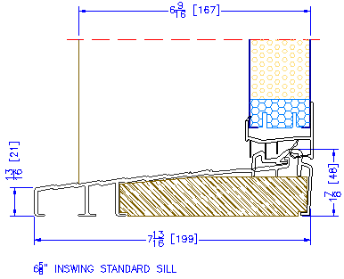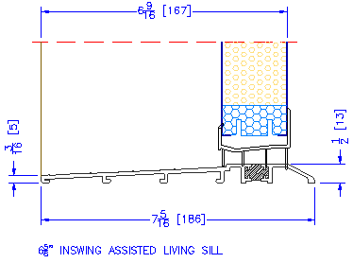

Out-swing Sill Options

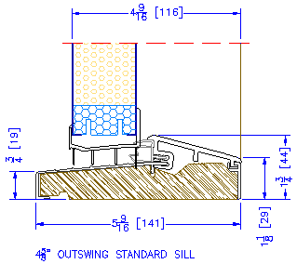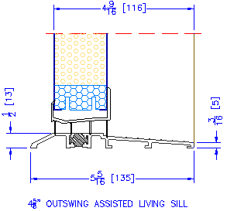

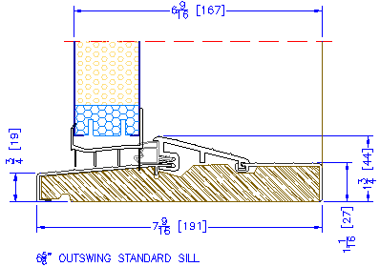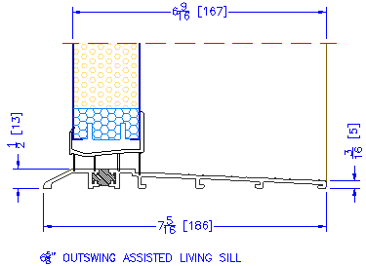

6-5/8” Out-swing Vented Panel
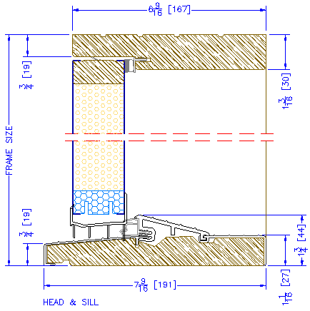

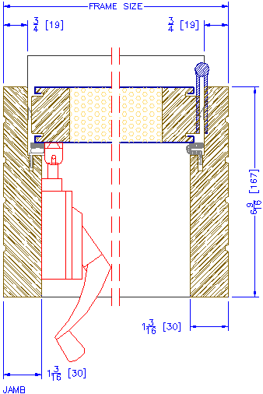

6-5/8” Out-swing Vented Panel – Vertical Mullion

