Kohltech International Architectural Details

Supreme Double Hung

System Features 2
Structural Performance 4
Thermal Performance 5
Section Details: Supreme Double Hung Head/Sill, Jamb Details 10
Section Details: Fixed Head/Sill, Jamb Details 12
Section Details: Supreme Double Glider Head/Sill, Jamb Details 13
Section Details: Supreme Double Hung Mullion Details 14
Section Details: Supreme Double Glider Mullion Details 16
Section Details: Supreme Double Hung/Glider Exterior Options 18
Section Details: Supreme Double Hung/Glider Interior Options 21

NOTE:
Specifications and technical data are subject to change without notice.
Allow 1/16” (2mm) tolerance on all measurements.
Metric measurements are shown in parenthesis.
For accessories dimensions and applications see the Accessories section of this manual.
For technical assistance you may call 1-800-565-4396 or visit our website:
www.peterkohler.com

System Features

Frame:
- Standard is white extruded polyvinyl chloride (uPVC) profiles. Optional tan extruded.
- Operator/Fixed Frame depth: 3.25” (83mm)
- Small Picture Window Frame depth: 3.25” (83mm). This profile is used for shapes.

Sash:
- Standard is white extruded polyvinyl chloride (uPVC) profiles. Optional tan extruded.

Interior and exterior finish
- Interior finish: Standard high gloss white. Optional tan.
- Exterior finish: Standard high gloss white. Optional tan
- Additional colours are also available: waterborne single component color coating system which is chemically bonded to the exterior vinyl surface.

Hardware
- Truth lock and keeper
- John Evans constant force balance
- Stainless pivot bars

Weather Stripping:
- Two pile weather strip on sash

Jamb Extensions:
- Jamb extensions available for various depths and factory applied.

Insect Screens:
- White aluminum full screen standard. Optional tan to match tan extruded frame and sash.
- Screen mesh: grey fiberglass standard.
- Pull tabs integrated into screen corner

Interior / Exterior Simulated Divided Lites (SDL):
- Interior bar: Extruded vinyl or wood, 3/4” and 1” wide bars. Standard white. Optional tan or painted.
- Exterior bar: Extruded vinyl, 3/4” and 1” wide bars. Standard white. Optional tan or painted.
- Pattern: Rectangular, custom lite layouts available, contact your Kohltech International representative

Between the Glass Grilles:
- 3/4” Contoured Georgian. Standard white. Optional tan, painted any standard color, or spilt finish interior/exterior.
- 1” Contoured Georgian. Standard white. Optional painted any standard color.
- 5/8” Flat Colonial. Standard white. Optional tan, brass, brushed aluminum, painted.
- Slimline 5/16” Flat Colonial. Standard white. Optional tan, pewter, black, gold, mill finish, painted.

Glazing:
- Glazing method: Insulated glass, hermetically sealed
- Glazing seal: Tape glazed, silicone heel bead
- Glazing type: Clear glass
- Spacer type: Warm edge steel Intercept
- Options: soft coat LoE, argon gas fill, obscure glass, tinted glass, Energlas (LoE/Argon and Stainless Steel spacer), Energlas Plus (triple paned, 2 panes with LoE glass, argon gas filling, and Edgetech warm edge Superspacer)

Accessories:
- Standard: ½” to ¾” return is built into the frame on the interior.
- Optional: 7/8”,1½”; 2”, or 3 ½” brick molding all four sides or with subsill. All available with J-trim and nailing fin. 2” and 3 ½” brick molds available with decorative backband molding.
- Installation brackets

Structural Performance

Supreme Double Hung Performance Data – CSA A440
 | Gateway Size | Air Resistance | Water Resistance | Wind Load Resistance
Supreme Double Hung | 39” x 63”  40" x 63" | A3  A3 | B3  B3 | C4  C4
Supreme Double Hung Picture | 78-7/8 x 78-7/8  50 x 100  72 x 84 | FX  FX  FX | B7  B7  B7 | C5  C3  C4
Supreme Double Glider | 63 x 44 | A2 | B3 | C4

Supreme Double Hung Series Performance Data - NAFS
 | Gateway Size | Rating | Canadian Air Infiltration
Supreme Double Hung | 39 x 63  40 x 63 | N/A  R-PG50-H | N/A  A3
Supreme Double Hung Picture | 78-7/8 x 78-7/8  50 x 100  72 x 84 | N/A  R-PG50-FW  CW-PG60-FW | FX  FX  FX
Supreme Double Glider | 63 X 44 | R-PG45-HS | A2

NAFS (AAMA/CSA-A440) Performance Grade Indicators
Product Performance Classes | Minimum Performance Grade | Minimum Design Pressure |  | Minimum Structural Test Pressure |  | Minimum Water Penetration Test Pressure
 | PG | psf | (Pa) | psf | (Pa) | psf | (Pa)
R – Residential | 15 | 15 | (719) | 2.90 | (137) | 2.90 | (137)
LC – Light Commercial | 25 | 25 | (1198) | 3.75 | (180) | 3.75 | (180)
CW – Commercial | 30 | 30 | (1437) | 4.50 | (217) | 4.50 | (217)
AW – Architectural | 40 | 40 | (1916) | 8.00 | (383) | 8.00 | (383)

Thermal Performance

Supreme Double Hung Average Unit Thermal Performance Data
 | U-value Btu/h•ft.²•°F (W/m²•K) | R-value | SHGC | VT | ER Number | Condensation Resistance | Canadian Energy Star Zone | US Energy Star
Supreme Double Hung
Clear | 2.7(0.47) | 2.13 | 0.57 | 0.61 | 14 | 47
LoE | 2.0(0.35) | 1.75 | 0.52 | 0.60 | 26 | 52 | AB
LoE/Argon | 1.8(0.32) | 3.13 | 0.53 | 0.60 | 30 | 55 | ABC | N
Energlas | 1.8(0.32) | 3.13 | 0.53 | 0.60 | 30 | 57 | ABC | N
Energlas-S | 1.8(0.32) | 3.13 | 0.53 | 0.60 | 30 | 58 | ABC | N
Triple LoEx1 LSG | 1.9(0.34) | 2.94 | 0.28 | 0.48 | 13 | 57 |  | SC
Triple LoE/Argonx1 LSG | 1.8(0.31) | 3.57 | 0.28 | 0.48 | 17 | 60 | A | NC,SC
Energlas Plus - Argon LSG | 1.5(0.26) | 3.57 | 0.24 | 0.41 | 21 | 62 | AB | N,NC,SC,S
Energlas Plus LSG | 1.2(0.21) | 4.76 | 0.23 | 0.41 | 26 | 63 | ABCD | N,NC,SC,S
Energlas Plus Argon | 1.5(0.27) | 3.7 | 0.45 | 0.54 | 32 | 62 | ABC | N
Energlas Plus | 1.3(0.23) | 4.34 | 0.45 | 0.54 | 37 | 62 | ABCD | N
LoE-LSG | 1.9(0.34) | 2.94 | 0.30 | 0.53 | 14 | 53 |  | SC
LoE/Argon-LSG | 1.8(0.31) | 3.23 | 0.29 | 0.53 | 17 | 56 | A | NC,SC
Energlas-LSG | 1.7(0.30) | 3.45 | 0.29 | 0.53 | 19 | 58 | A | N,NC,SC
Energlas-S-LSG | 1.7(0.30) | 3.45 | 0.29 | 0.53 | 19 | 59 | A | N,NC,SC

Supreme Double Hung Average Unit Thermal Performance Data
 | U-value Btu/h•ft.²•°F (W/m²•K) | R-value | SHGC | VT | ER Number | Condensation Resistance | Canadian Energy Star Zone | US Energy Star
Supreme Double Glider
Clear | 2.7(0.47) | 2.13 | 0.57 | 0.61 | 14 | 47
LoE | 2.0(0.35) | 1.75 | 0.52 | 0.60 | 24 | 52 | A
LoE/Argon | 1.8(0.32) | 3.13 | 0.52 | 0.60 | 28 | 55 | AB | N
Energlas | 1.8(0.32) | 3.13 | 0.52 | 0.60 | 28 | 57 | AB | N
Energlas-S | 1.8(0.32) | 3.13 | 0.52 | 0.60 | 28 | 57 | AB | N
Triple LoEx1 LSG | 1.9(0.34) | 2.94 | 0.28 | 0.48 | 12 | 56 |  | SC
Triple LoE/Argonx1 LSG | 1.8(0.31) | 3.57 | 0.27 | 0.48 | 15 | 59 | A | NC,SC,S
Energlas Plus - Argon LSG | 1.5(0.26) | 3.85 | 0.24 | 0.41 | 19 | 63 | AB | N,NC,SC,S
Energlas Plus LSG | 1.2(0.21) | 4.76 | 0.23 | 0.41 | 25 | 64 | ABCD | N,NC,SC,S
Energlas Plus Argon | 1.5(0.27) | 3.7 | 0.45 | 0.54 | 30 | 62 | ABC | N
Energlas Plus | 1.3(0.23) | 4.35 | 0.45 | 0.54 | 35 | 64 | ABCD | N
LoE-LSG | 1.9(0.34) | 2.94 | 0.29 | 0.53 | 12 | 53 |  | SC
LoE/Argon-LSG | 1.8(0.31) | 3.45 | 0.29 | 0.53 | 16 | 56 | A | NC,SC
Energlas-LSG | 1.7(0.30) | 3.45 | 0.29 | 0.53 | 17 | 58 | A | N,NC,SC
Energlas-S-LSG | 1.7(0.30) | 3.45 | 0.29 | 0.53 | 17 | 58 | A | N,NC,SC

Supreme Double Hung Average Unit Thermal Performance Data
 | U-value Btu/h•ft.²•°F (W/m²•K) | R-value | SHGC | VT | ER Number | Condensation Resistance | Canadian Energy Star Zone | US Energy Star
Supreme Double Hung Picture Window
Clear | 2.6(0.46) | 2.17 | 0.61 | 0.64 | 18 | 47
LoE | 1.9(0.33) | 3.03 | 0.56 | 0.64 | 31 | 54 | ABC
LoE/Argon | 1.7(0.30) | 3.33 | 0.56 | 0.64 | 35 | 57 | ABCD | N
Energlas | 1.7(0.30) | 3.33 | 0.56 | 0.64 | 35 | 59 | ABCD | N
Energlas-S | 1.6(0.29) | 3.45 | 0.56 | 0.64 | 36 | 59 | ABCD | N
Triple LoEx1 LSG | 1.8(0.32) | 3.13 | 0.29 | 0.51 | 17 | 59 | A | NC,SC
Triple LoE/Argonx1 LSG | 1.6(0.29) | 3.45 | 0.29 | 0.51 | 22 | 62 | AB | N,NC,SC
Energlas Plus - Argon LSG | 1.3(0.23) | 4.35 | 0.25 | 0.44 | 26 | 66 | ABC | N,NC,SC,S
Energlas Plus LSG | 1.0(0.18) | 5.56 | 0.25 | 0.44 | 32 | 67 | ABCD | N,NC,SC,S
Energlas Plus Argon | 1.4(0.25) | 4 | 0.48 | 0.58 | 36 | 66 | ABCD | N
Energlas Plus | 1.1(0.20) | 5 | 0.48 | 0.58 | 43 | 67 | ABCD | N
LoE-LSG | 1.8(0.32) | 3.13 | 0.31 | 0.56 | 18 | 55 | A
LoE/Argon-LSG | 1.6(0.28) | 3.57 | 0.31 | 0.56 | 23 | 58 | AB | N,NC
Energlas-LSG | 1.5(0.27) | 3.7 | 0.31 | 0.56 | 24 | 61 | AB | N,NC
Energlas-S-LSG | 1.5(0.27) | 3.7 | 0.31 | 0.56 | 24 | 60 | AB | N,NC

Canadian Energy Star Climate Zones
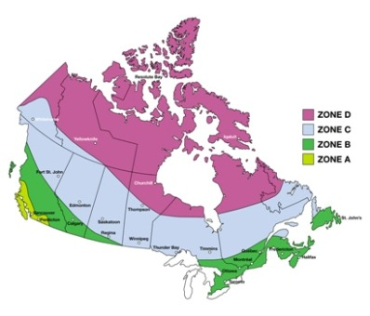

Energy Star Requirements for Windows ⁽²⁰⁰⁴⁾
 |  | Maximum U-values  and Minimum R-Values |  |  |  |  | Minimum  Energy Rating (ER) Values  (Maximum U-value 2.00 W/m²•K)
Zone | U-value  (W/m²•K) |  | U-value  (Btu/h•ft.²•°F) | R-Value  (ft.²•h•°F/Btu) |  |  |  | Operating Windows | Fixed  Windows
A | 2.00 |  | 0.35 | 2.9 |  | Or |  | 17 | 27
B | 1.80 |  | 0.32 | 3.2 |  | Or |  | 21 | 31
C | 1.60 |  | 0.28 | 3.6 |  | Or |  | 25 | 35
D | 1.40 |  | 0.25 | 4.0 |  | Or |  | 29 | 39

For more information please visit:
http://oee.nrcan.gc.ca/energystar/english/consumers/ratings.cfm

United States Energy Star Climate Zones

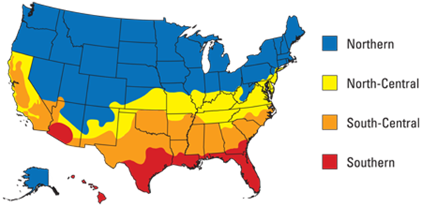

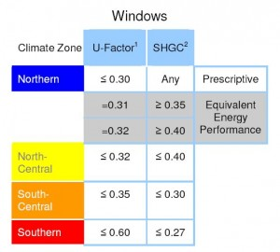

Section Details: Supreme Double Hung Head/Sill, Jamb Details

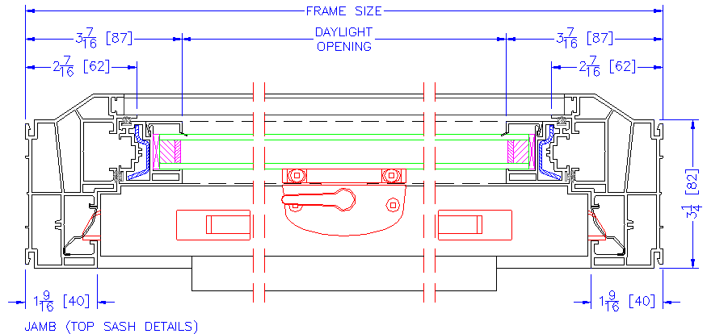

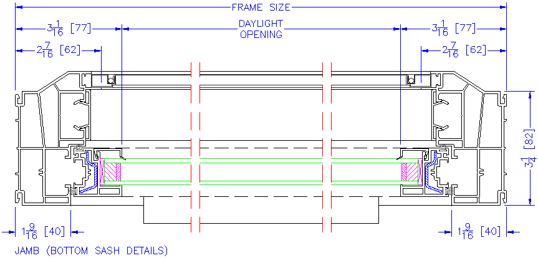

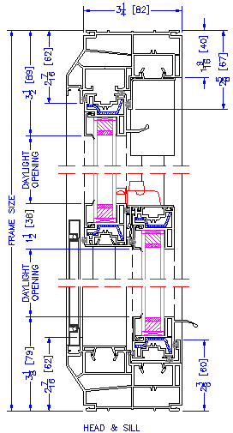

Section Details: Fixed Head/Sill, Jamb Details

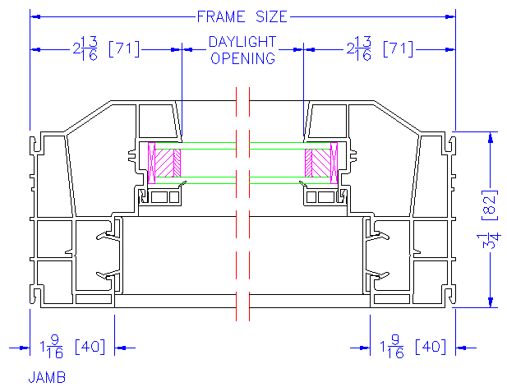

Section Details: Supreme Double Glider Head/Sill, Jamb Details

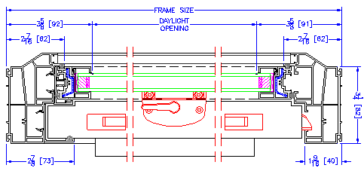


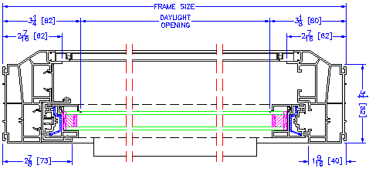


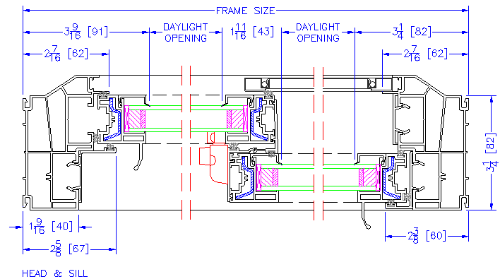

Section Details: Supreme Double Hung Mullion Details

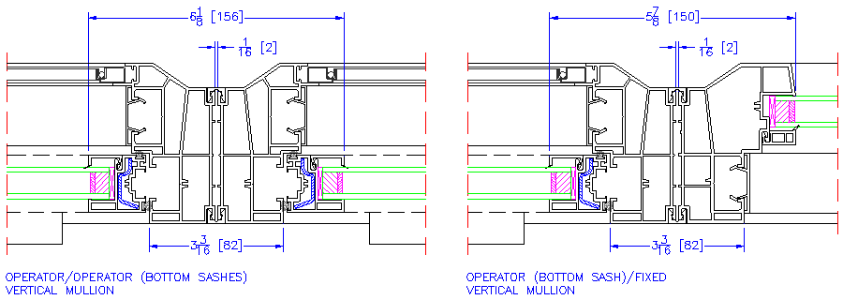

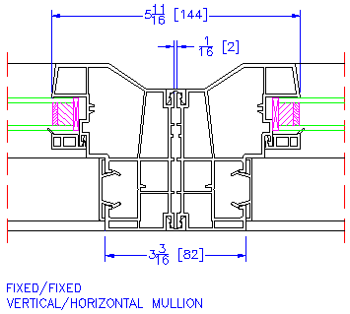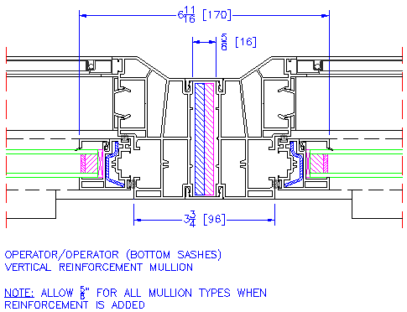

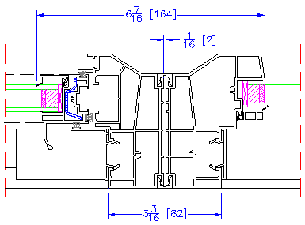

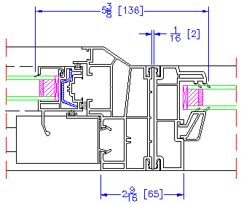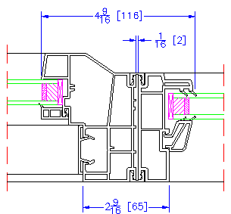

Section Details: Supreme Double Glider Mullion Details

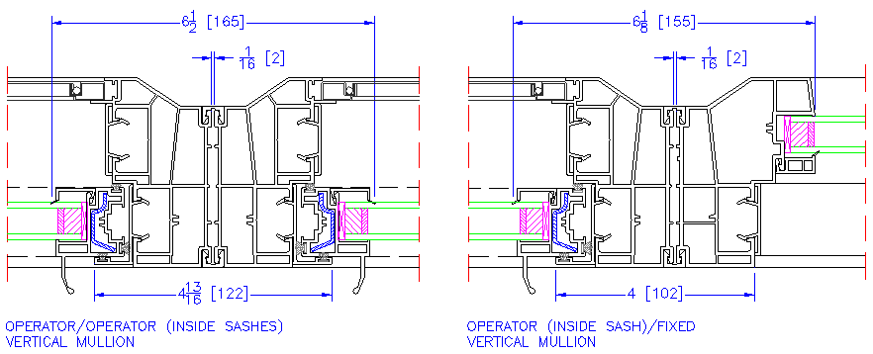

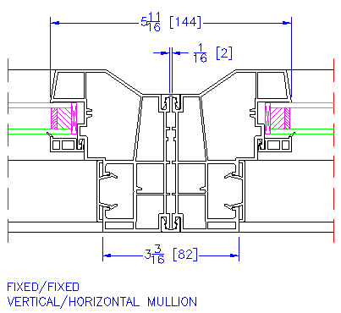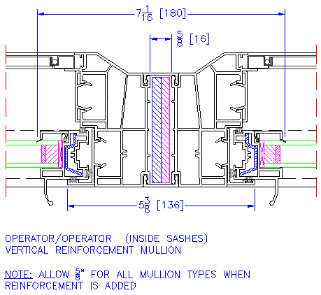


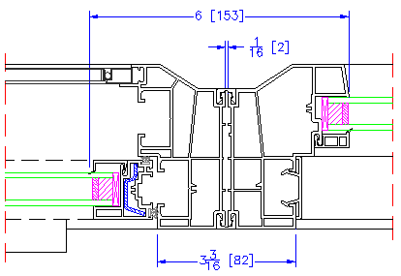


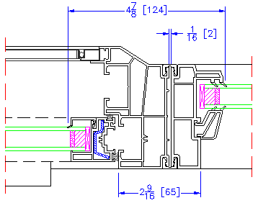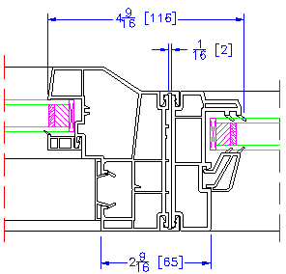

Section Details: Supreme Double Hung/Glider Exterior Options

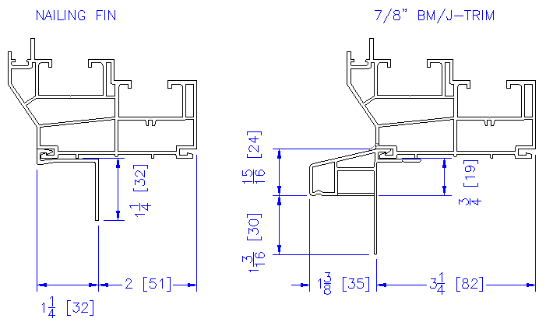

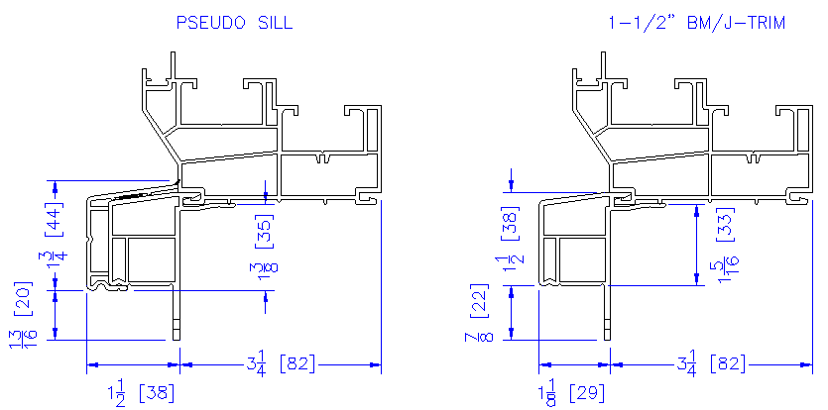

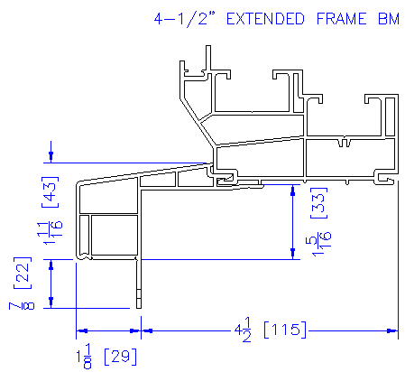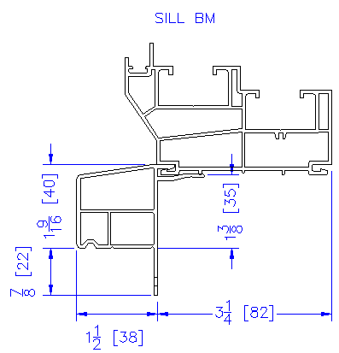

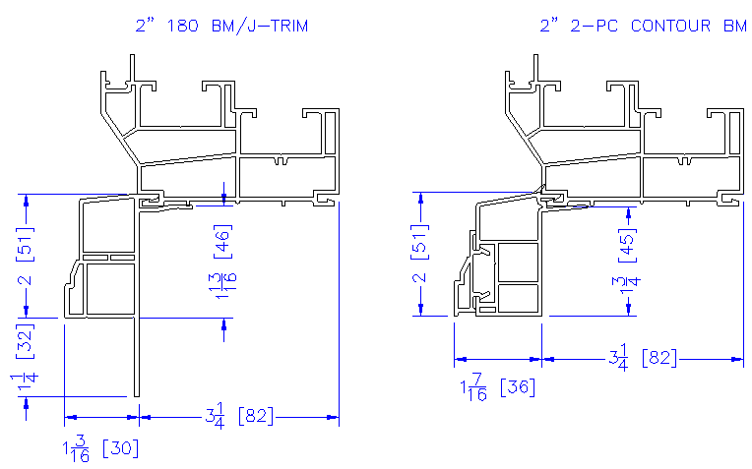

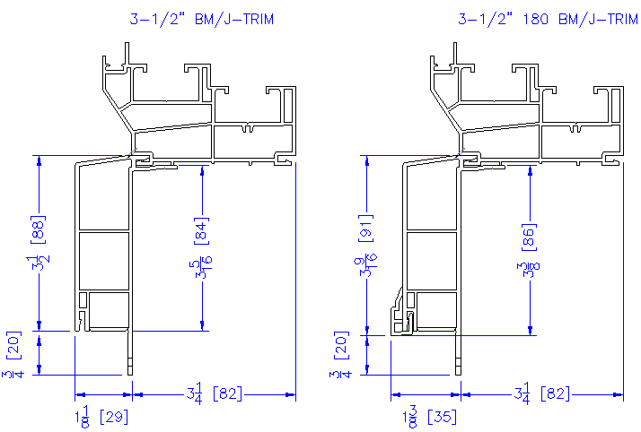

Section Details: Supreme Double Hung/Glider Interior Options

